

**User Manual**

Table of Contents

Introduction 2

Getting Started 3

Contact 3

Innoventory Desktop 4

Logging in 5

Creating an Account 6

Searching for an item 8

Finding Checkout Page 13

Shopping Cart 15

Updating Quantity 16

Removing an Item 17

Checking out 18

Logging Out 21

Closing Innoventory 23

Innoventory Mobile 24

Getting Started 25

The Login Screen 25

The Account Creation Screen 26

The Home Screen 27

The Results Page 29

The Product Info Screen 31

The Shopping Cart 35

The Settings Page 39

The Change Password Screen 40

## Introduction

Thank you for downloading Innoventory! The following user manual will get you on track to making sure your experience with our app is as user-friendly as possible. Pictures and step-by-step instructions are included that will take you through all of Innoventory’s features.

There are two sections in this manual: Innoventory desktop and Innoventory mobile. Please make sure you are reading the correct section based on your platform platform

## Getting Started

To start up Innoventory, simply look in the Innoventory zip file you downloaded and locate the Innoventory.exe file. Upon clicking the .exe file, Innoventory should start up. If Innoventory does not start up upon clicking, your antivirus and/or firewalls may be blocking the program.

## Contact

If you have any questions or complaints that are not solved by this user manual, you may contact us through email at [samer.khamaiseh@msutexas.edu](mailto:samer.khamaiseh@msutexas.edu). Our services will be open at all times to assist with your needs. Our trained staff are also very patient and respectful to all individuals.



# Innoventory Desktop

## Logging in

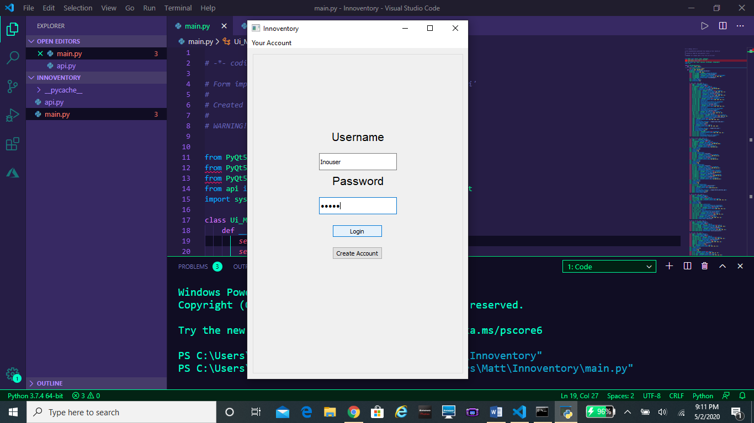

Upon starting Innoventory desktop, you will see the login page. In order to log in to Innoventory, enter your username and password into the specified input fields and click “Login”. If you do not currently have an Innoventory account, then click on the “Create Account” button in order to begin setting up and account.

## Creating an Account

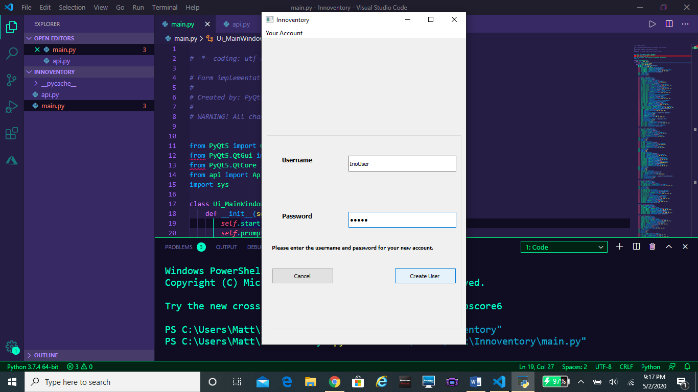

Clicking on the Create Account button will take you to a new window where you may begin setting up your account. To set up an account you must simply:

1. Enter your username and password into the required fields
2. Click on the Create User button after both input fields are filled in.

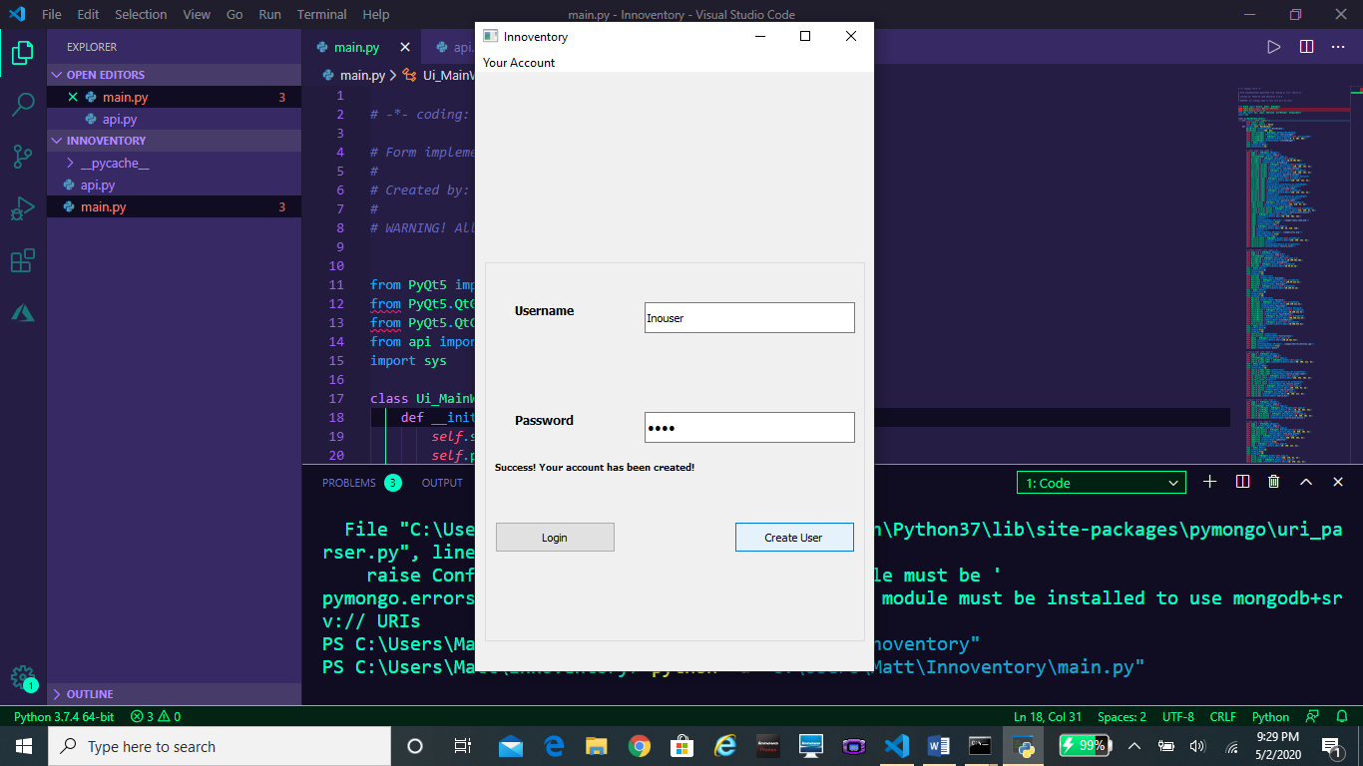

If account creation was successful, a message will be printed out stating “Your account has successfully been created!” From here, you may click on the cancel button to return to the original login screen, and proceed to log in to Innoventory.

## Searching for an item

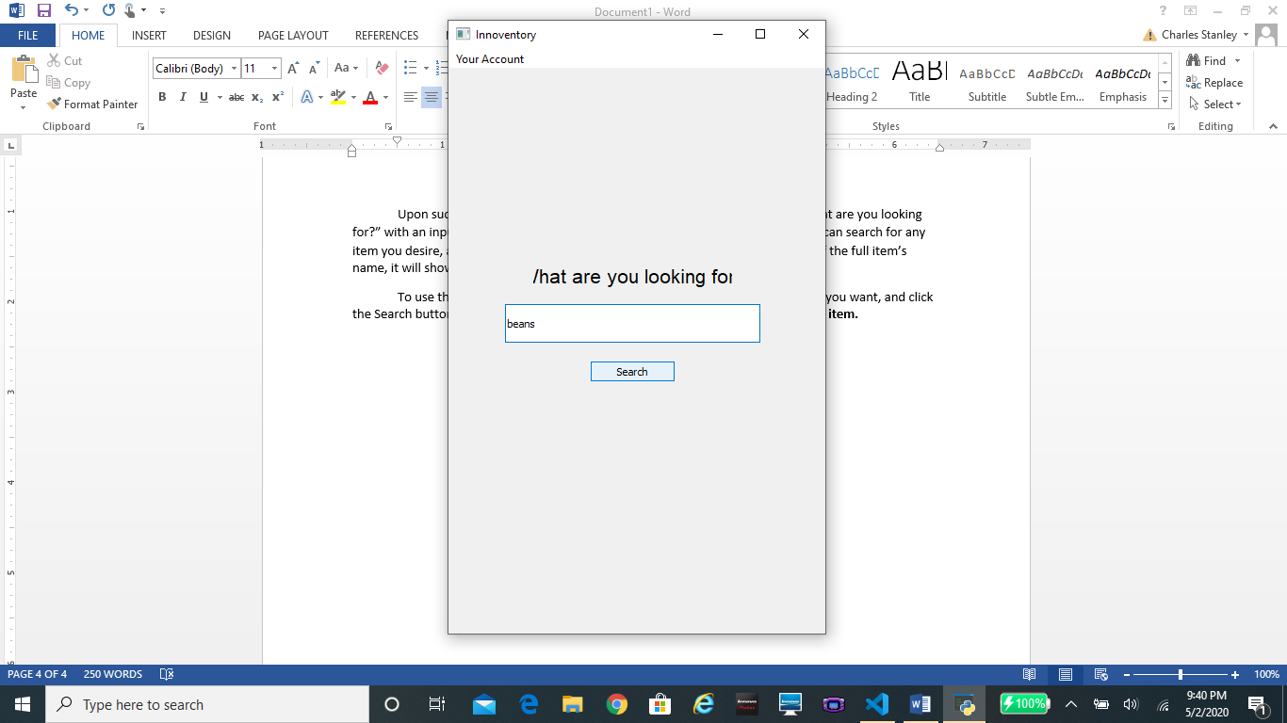

Upon successfully logging in, you will be greeted with a window asking “What are you looking for?” with an input field underneath. This is the item search screen. From here, you can search for any item you desire, and see if it is currently in the database. If your item’s name is a substring of an available item’s name, it will show up as well. To use the search feature, all you have to do is type in the name of the item you want, and click the Search button. **Note: Only use lowercase letters when typing in the name of an item.**

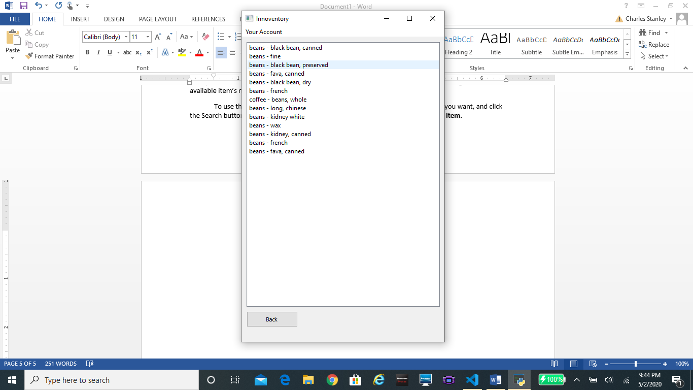

After pressing “Search”, you will be presented with a list of items that match your input query. If you would like more information about an item, then simply hover over it with your mouse. As can be seen in the image above, the area around that item will become highlighted. If you click in the highlighted area, you will be taken to that item’s information page.

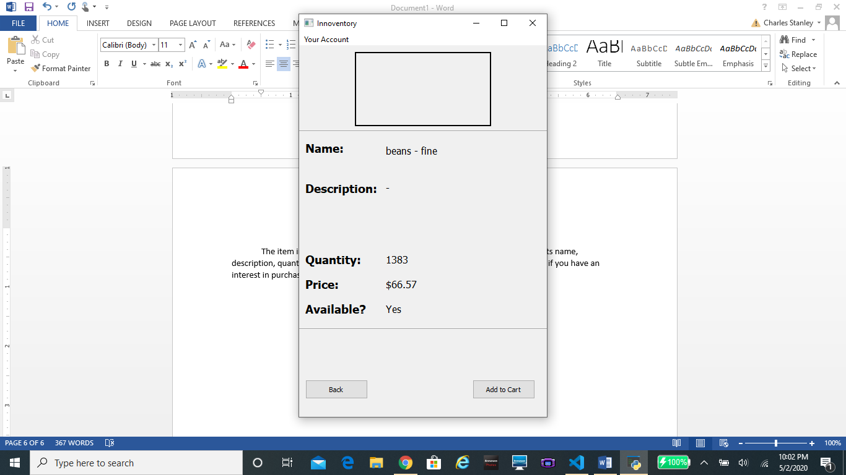

The item information page contains detailed information on an item such as its name, description, quantity in stock, price, and availability. After reviewing this information, if you have an interest in purchasing the item then simply click the “Add to Cart” button.

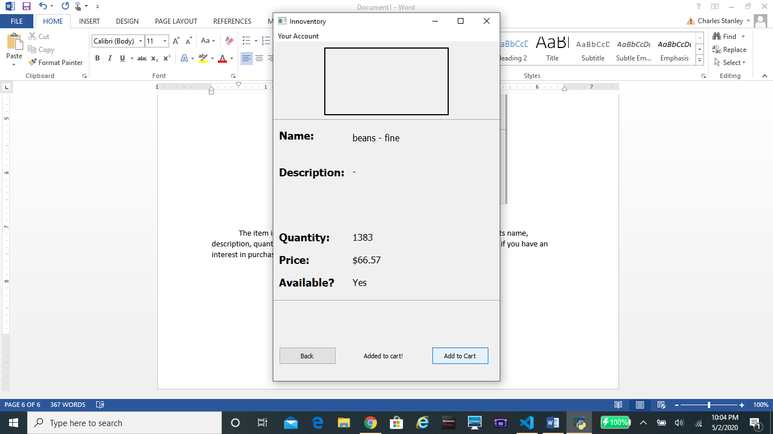

If the item was available, you will receive a message stating it was added to your cart. If you want to purchase more of this item, you can click “Add to Cart” again, but it is much easier to add to your quantity in the shopping cart window. From here, you may click the “Back” button to return to the previous list of items or proceed to the “Shopping Cart” page to complete your transaction.

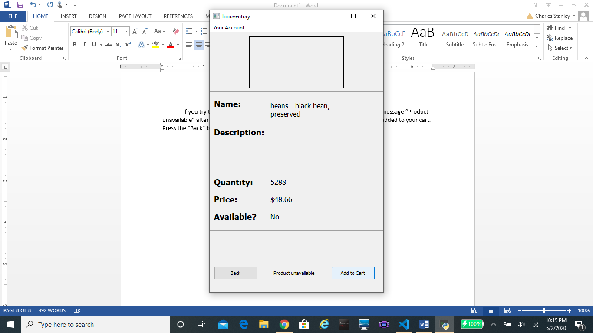

If you attempt to purchase an item that is currently not available, you will see the message “Product unavailable” after clicking the “Add to Cart” button. In this case, the item will not be added to your cart. Press the “Back” button to return to the list of searched items

## Finding Checkout Page

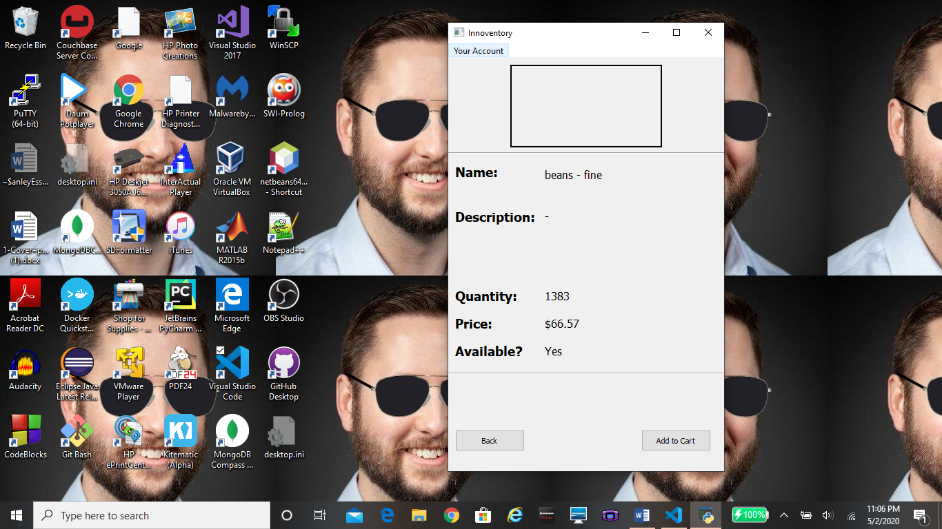

Click here to open drop down tab

Once you have finished adding items to your cart, you will need to head to the Shopping Cart page in order to checkout. To access the Shopping Cart page, move your mouse to the top left corner of the window and click the drop down tab labeled “Your Account”.

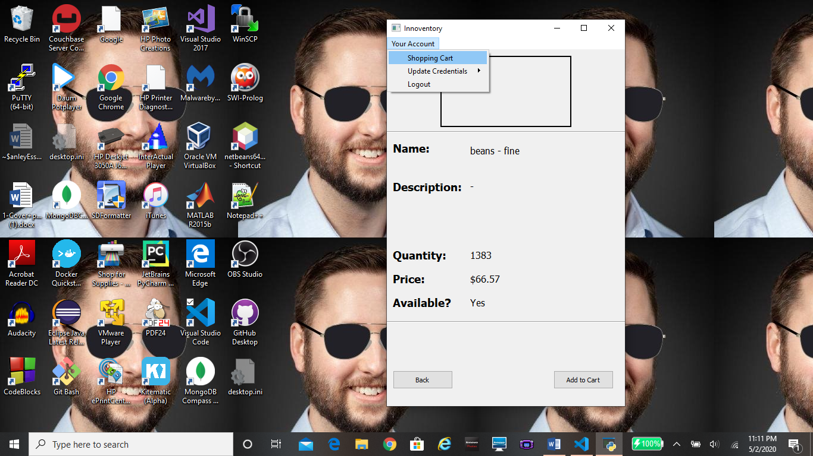

Clicking the “Your Account” dropdown tab will open up a small tab that contains the sections, Shopping Cart, Change Password, and Logout. Move the mouse into the Shopping Cart section and it should become highlighted. From here, just click and you will be taken to the “Shopping Cart” window.

## Shopping Cart

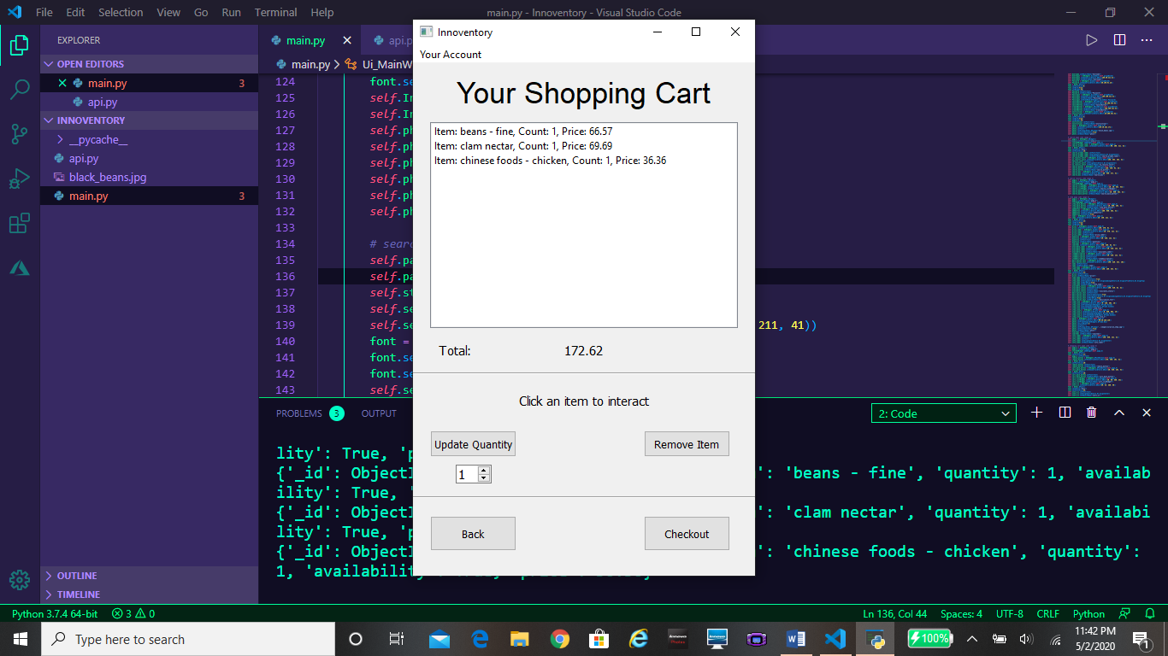

Upon clicking the “Shopping Cart” tab, you will be presented with the shopping cart window. This window shows the items currently in your cart along with how many of each item you currently have.

## Updating Quantity

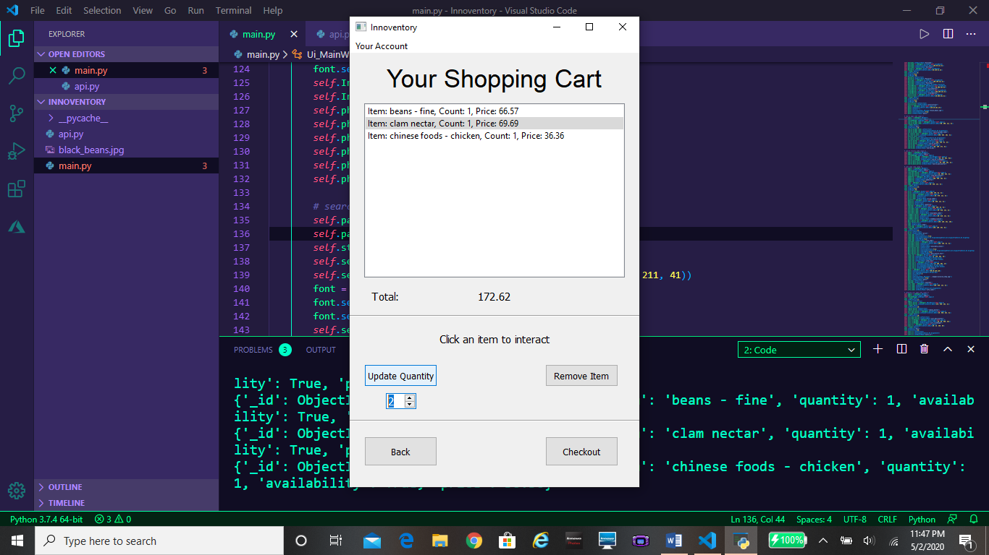 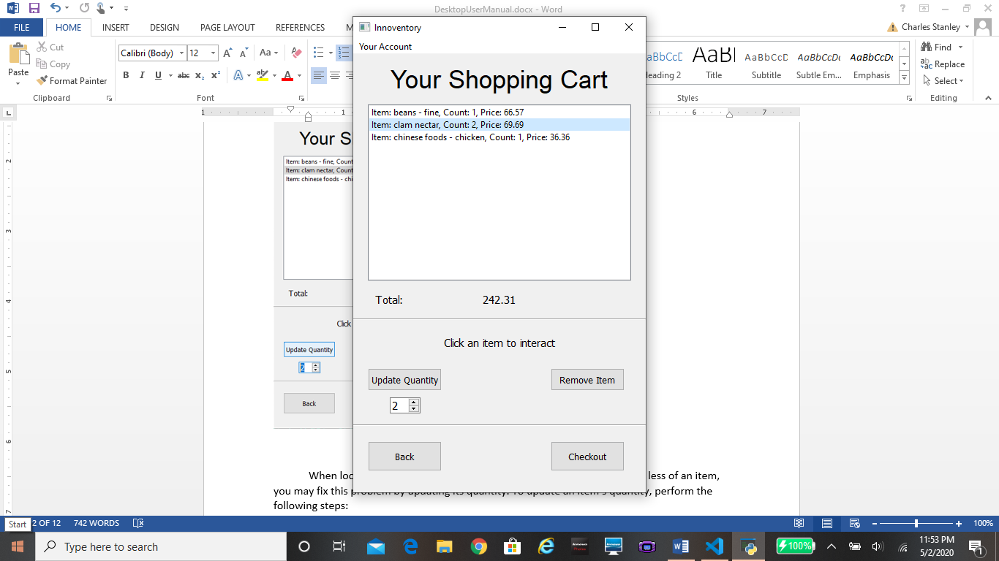

When looking at the items in your cart, if you decide you want more or less of an item, you may fix this problem by updating its quantity. To update an item’s quantity, perform the following steps:

1. Click on the item in the cart. The area around it should be highlighted blue.
2. In the fill in box under the “Update Quantity” button, press the down and up arrows to increment or decrement the number inside the box until it matches the quantity you desire. Alternatively, you may just type in the number into the box directly.
3. Click on the “Update Quantity” button.

## Removing an Item

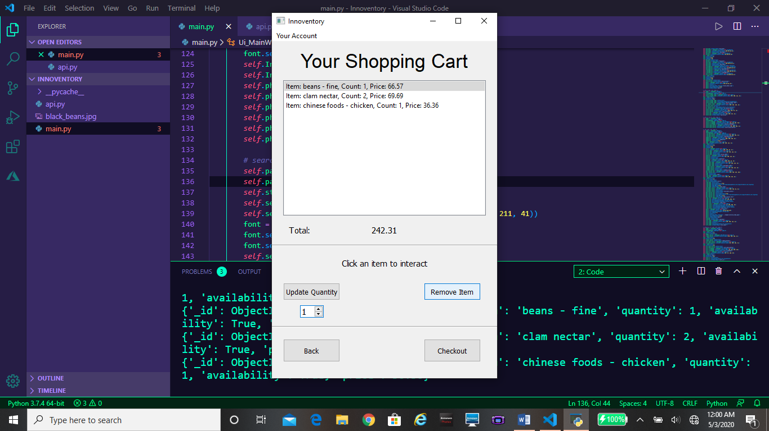 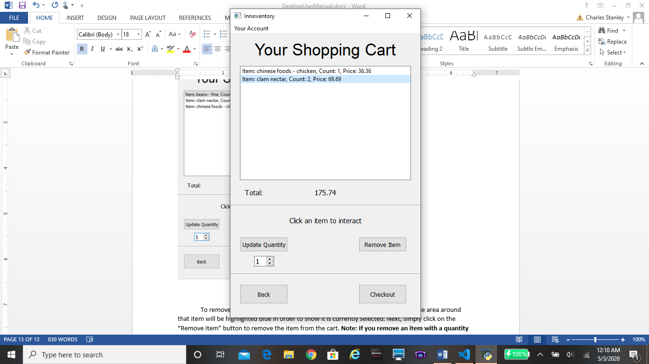

To remove an unwanted item in your cart, first click on that item in the list. The area around that item will be highlighted blue in order to show it is currently selected. Next, simply click on the “Remove Item” button to remove the item from the cart. **Note: If you remove an item with a quantity greater than 1, all amounts of that item will be removed from your cart. Use update quantity if you only want to lower the quantity of an item.**

## Checking out

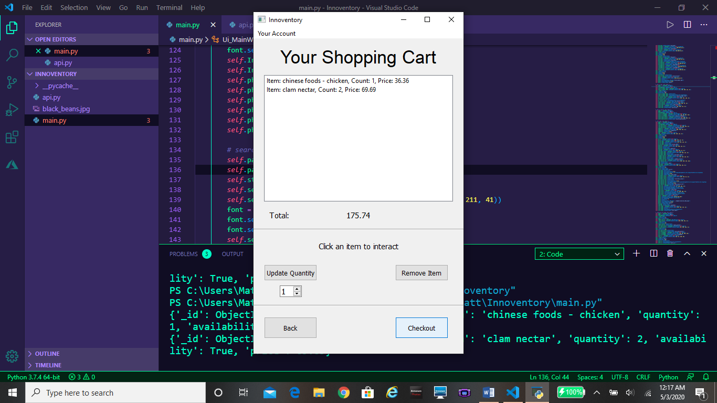

Once you are satisfied with the items in your cart, you may checkout by clicking the “Checkout” button on the Shopping Cart window.

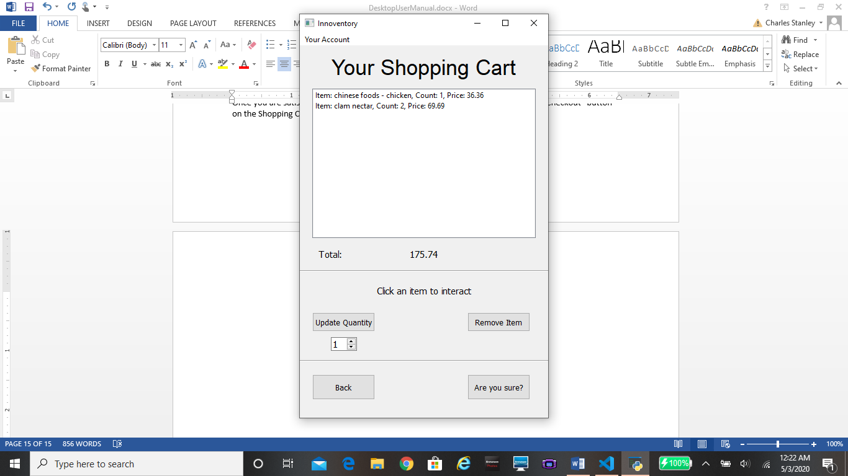

Upon clicking the “Checkout” button, the text on it will change to “Are you sure?” This gives you one final chance to look over your shopping cart and make sure you are satisfied with your purchase. If you are still ready to checkout, press the “Are you sure?” button to complete your purchase.

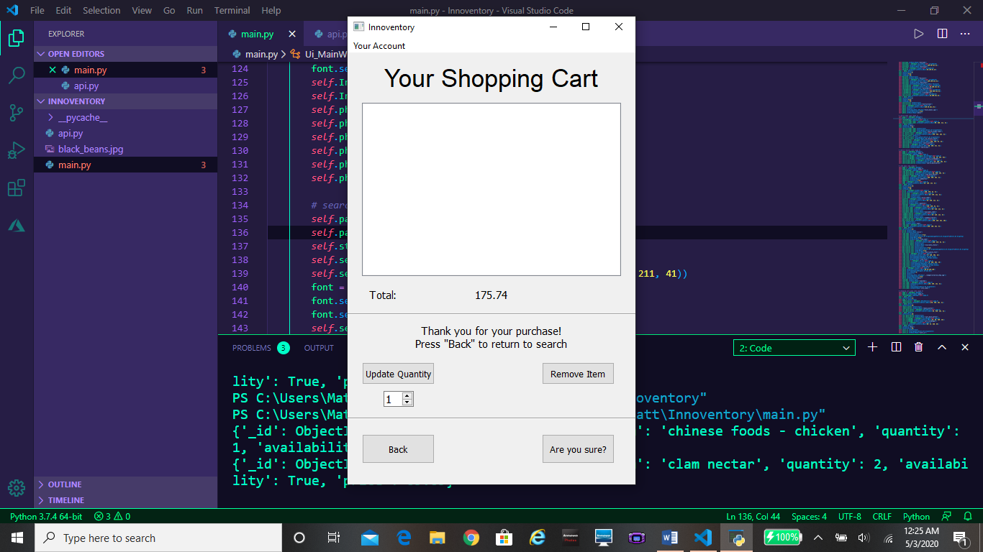

After clicking the button once more, your transaction will be complete. A message will appear on screen thanking you from your purchase. From here, you may click the “Back” button in order to search for items again, or log out of Innoventory through the “logout” tab under “Your Account”.

## Logging Out

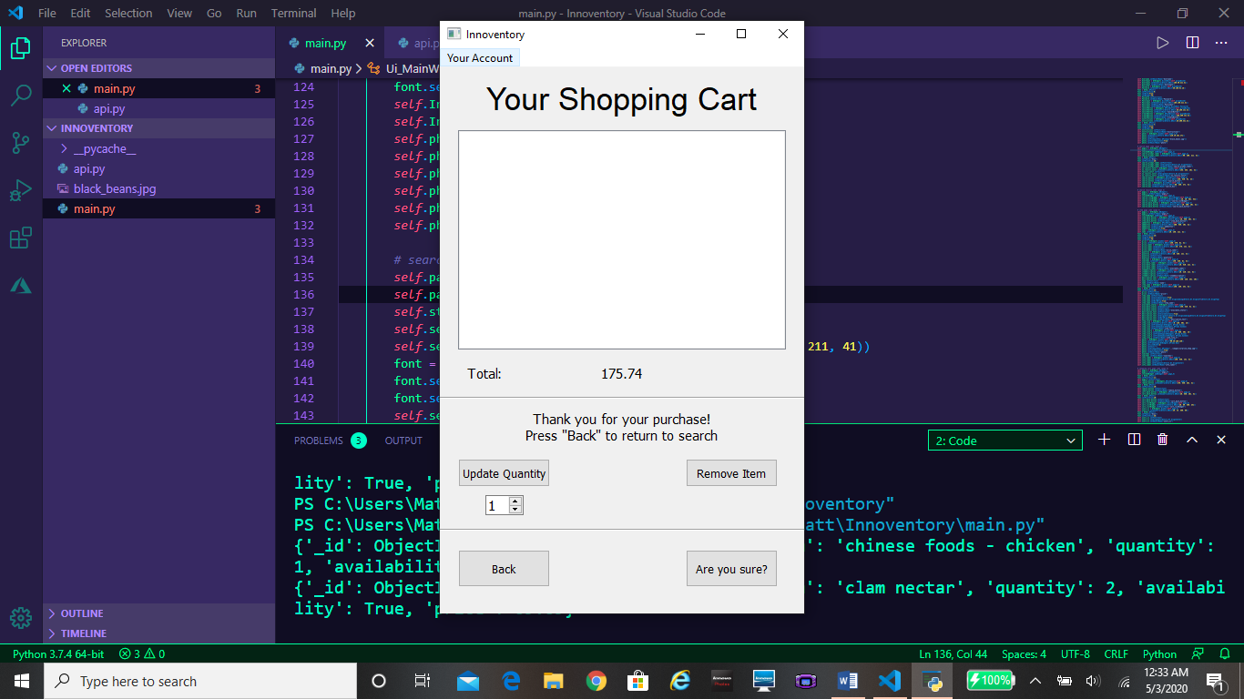

When you have finished your business on Innoventory, you should log out. To log out, first move your mouse over to the left hand corner of the window, and click on the “Your Account” drop down menu.

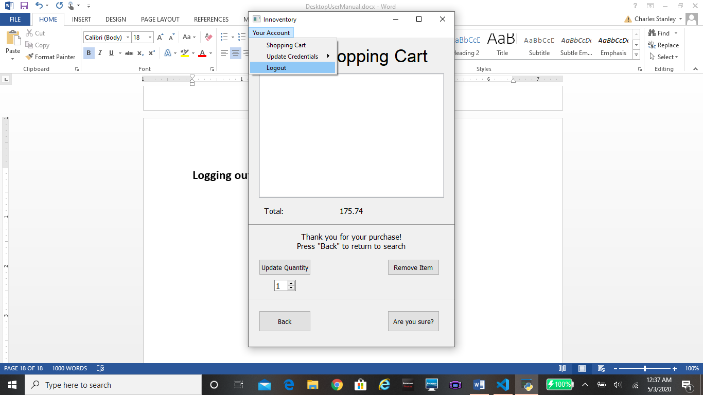

In the drop down menu, you will see a logout option. Hover your mouse over this area and it will be highlighted blue. While highlighted, click in this area to successfully log out of Innoventory. After clicking, you will be returned to the Login page.

## Closing Innoventory

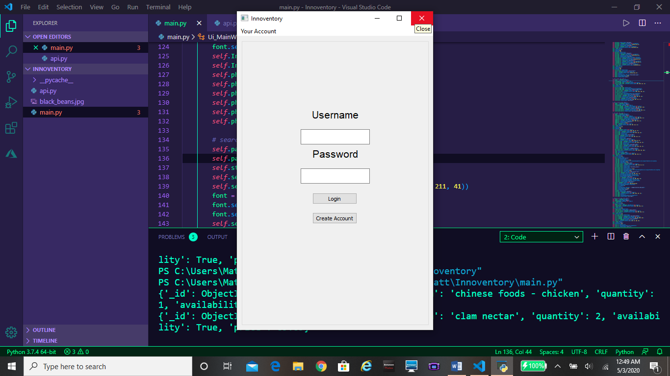

If you want to close Innoventory, simply move your mouse to the top right corner of the screen and hover over the “x” button. Upon clicking this button, Innoventory will close.



# Innoventory Mobile

## Getting Started

Welcome to the Innoventory Mobile User Manual. In this Manual, we will discuss the functionalities of Innoventory Mobile while showing how to purchase an item step by step. First, run Innoventory Mobile.exe by double clicking its icon.

## The Login Screen

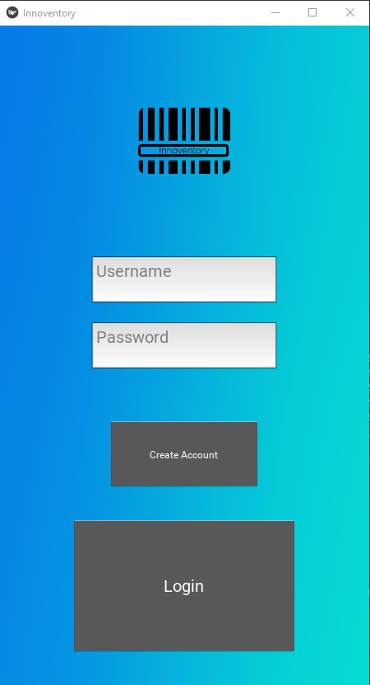

The first page you’ll see upon running Innoventory Mobile is the Login page. From this page you can log in by typing your username and password in the white text boxes labelled “Username” and “Password,” respectively, and then clicking the gray “Login” button. If you’re a new user, you can create an account by clicking the gray “Create Account” button, which will take you to the account creation screen.

## The Account Creation Screen

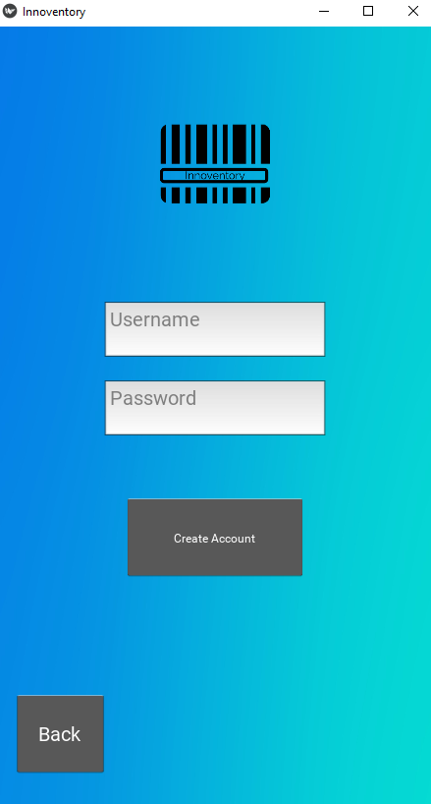

The account creation screen lets you create an Innoventory account that you can use to login. To create an account, type a username of your choice, and a password of your choice into the white text boxes labelled “Username” and “Password,” respectively. Then click the gray “Create Account” button. This will take you to the home screen.

## The Home Screen

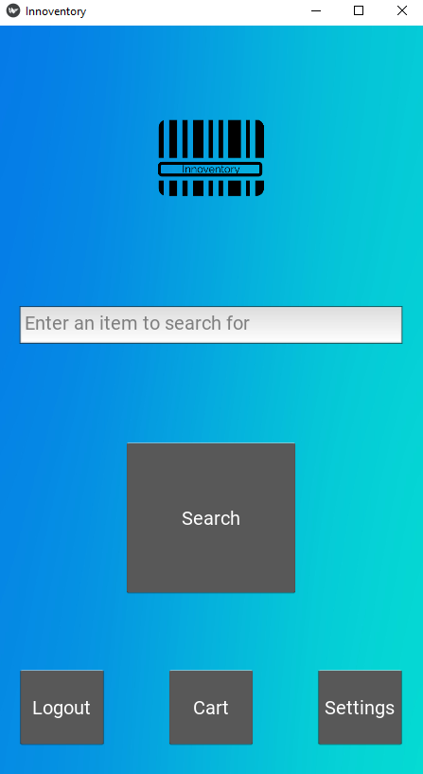

Welcome to the home screen, this is the main hub of Innoventory mobile. From here you can search for an item, log out of Innoventory, view your shopping cart, or go to the settings page.

* To search, type one or more words into the text box labelled “Enter an item to search for.” Then hit the gray “Search” button. This will take you to the results page.
* To log out, click the gray “Logout” button. This will take you back to the login creen.
* To view your shopping cart, click the gray “Cart” button.
* To go to the settings page, click the gray “Settings” button.

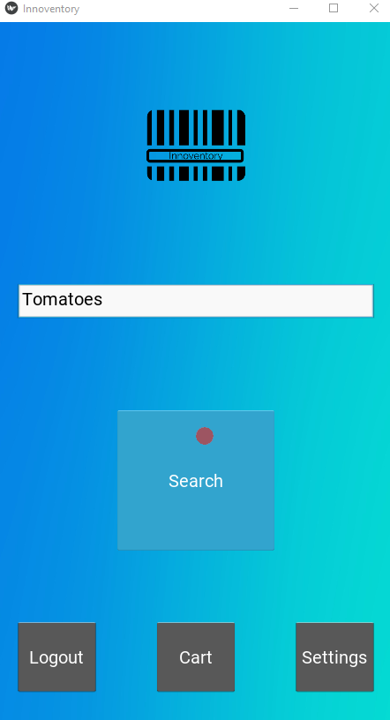

We’ll come back to the settings page later. Right now, we’ll search for “Tomatoes” and click “Search”.

## The Results Page

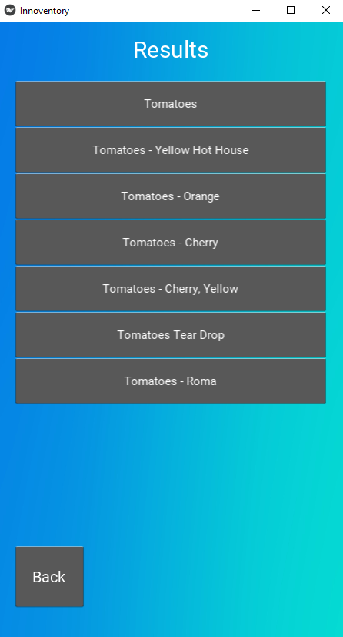

The results page lists all the items relevant to your search. Above, we can see the results for our search. If we click on the gray “Back” button, we’re taken back to the home screen.

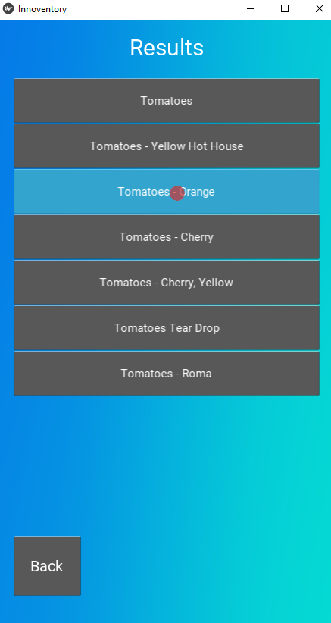

If we click on one of the item boxes, it will take us to the product info page for that item. We will click on “Tomatoes – Orange.”

## The Product Info Screen

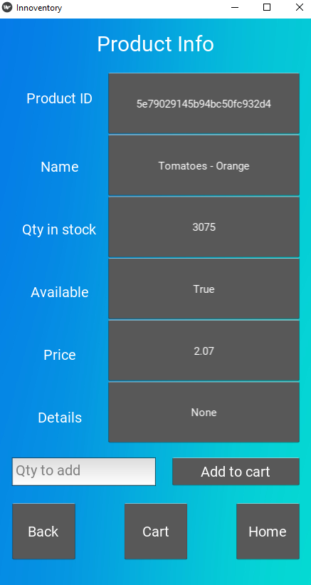

The product info page displays information about the item you’ve selected from the results list. “Qty in stock” shows how many of the item there are to buy. “Available” shows whether or not the item is available for purchase. It is possible for an item to be in stock but not available to purchase. “Price” shows how much a single item will cost. Details includes extra information for some products, such as the year it was manufactured.

* The “Back” button will take you back to the results page
* The “Cart” button will take you to your shopping cart
* The “Home” button will take you to the home screen

To add an item to your cart, type the number you would like to add in the text box labelled “Qty to add,” then click the gray “Add to cart” button.

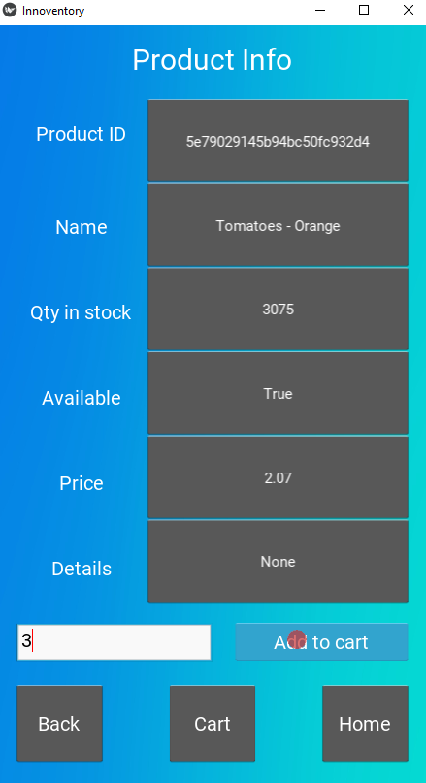

We will add 3 tomatoes to our cart by typing 3 in the “Qty to add” text box, and then clicking “Add to cart.”

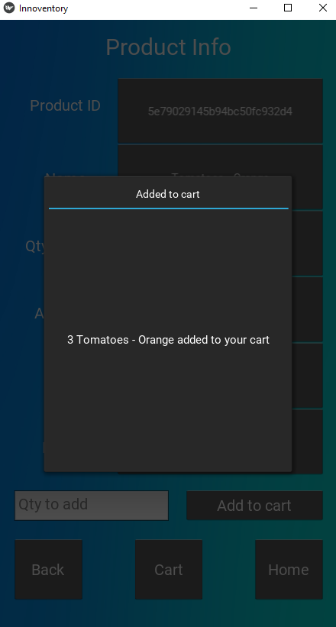

We are shown a confirmation message that the items have been added to our cart.

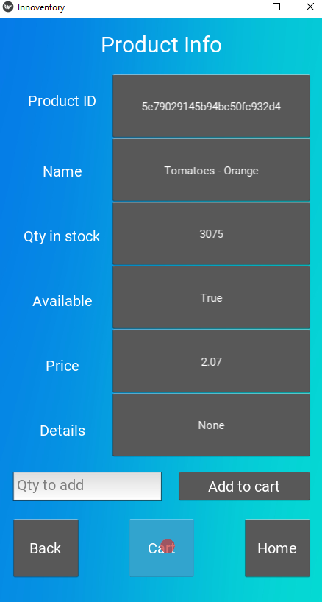

Now we will click outside the popup to close it, and click the “Cart” button to go to our shopping cart.

## The Shopping Cart

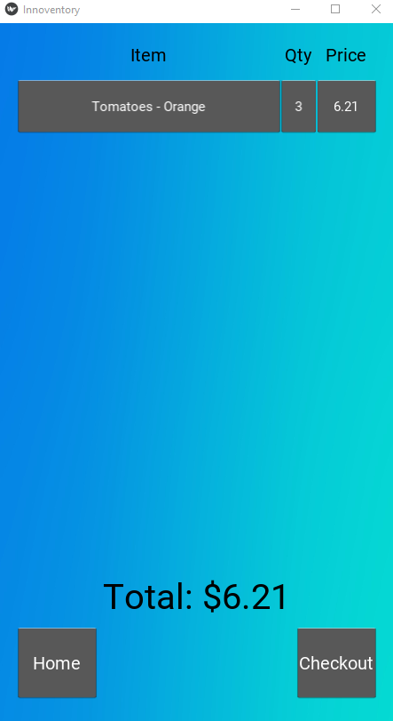

The shopping cart page shows you what items are in your cart, how many are in there, and the total price for each item in your cart. At the bottom, it shows your grand total for all items. The “Home” button will take you to the homepage.

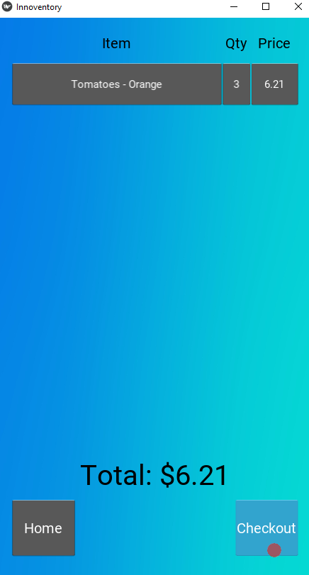

The “Checkout” button will open a popup window that prompts you to confirm the purchase. We will click the “Checkout” button.

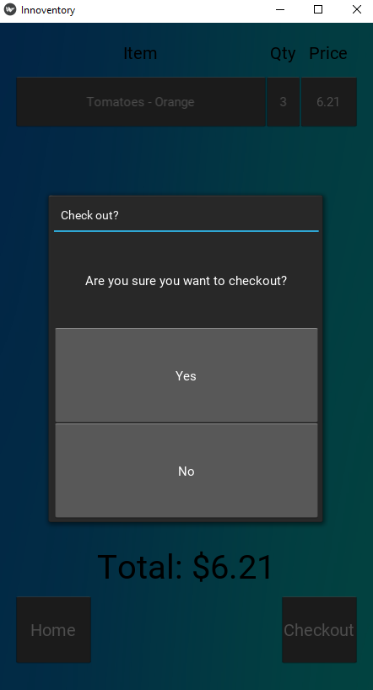

In the confirmation popup, clicking “Yes” will confirm the purchase and return you to the home page. Clicking “No” will cancel the purchase and return you to the shopping cart. We will click “Yes” and return to the home page.

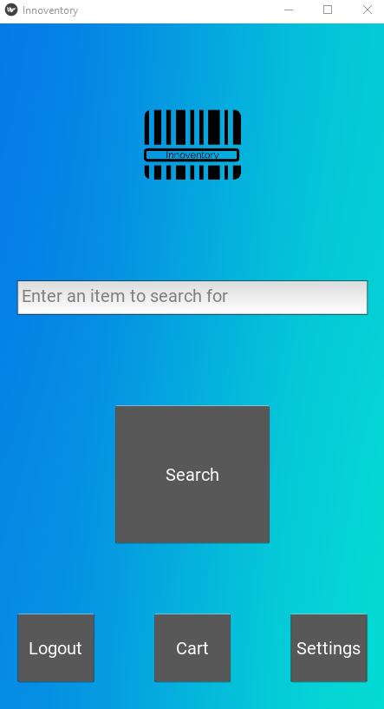

Congratulations, you’ve made your first purchase on Innoventory Mobile! Now we will discuss the settings page

## The Settings Page

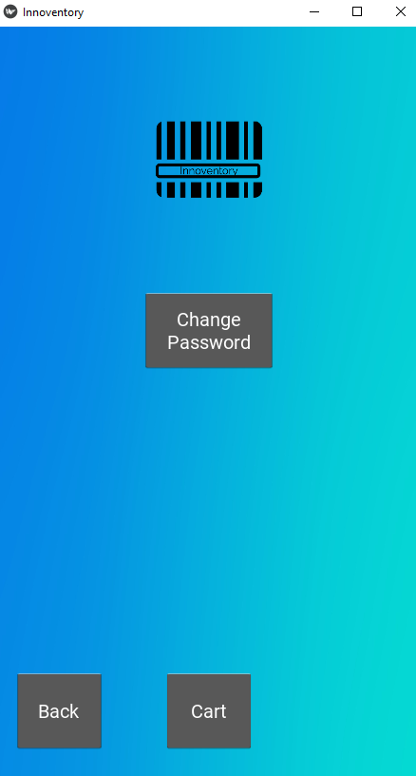

The settings page allows you to change your password. If you click the “Back” button, you will be returned to the home page. If you click the “Cart” Button, you’ll be shown your shopping cart. Let’s click the “Change Password” Button, which will take us to the “Change Password” screen.

## The Change Password Screen

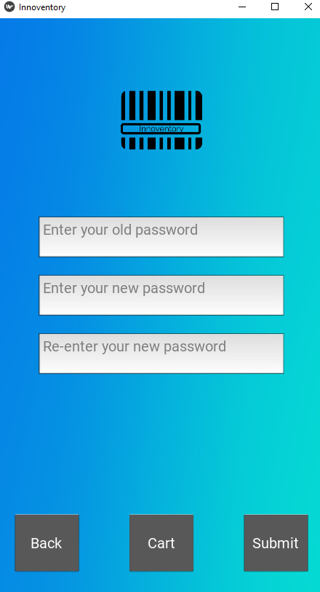

The change password screen allows you to change your password. To do this, type in your old password in the text box labelled “Enter your old password.” Then type your new desired password in the text box labelled “Enter your new password.” Next, re-enter your new password in the text box labelled “Re-enter your new password.”

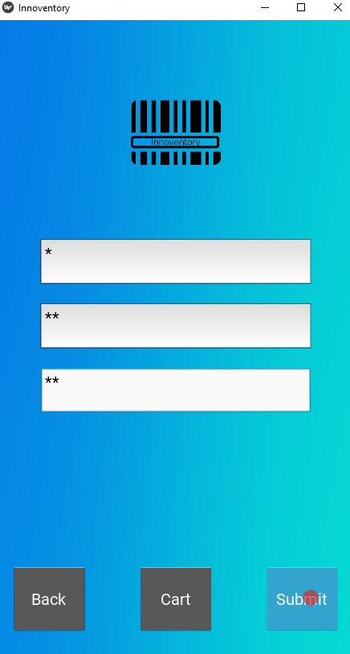

Finally, click the “Submit” button to change your password.

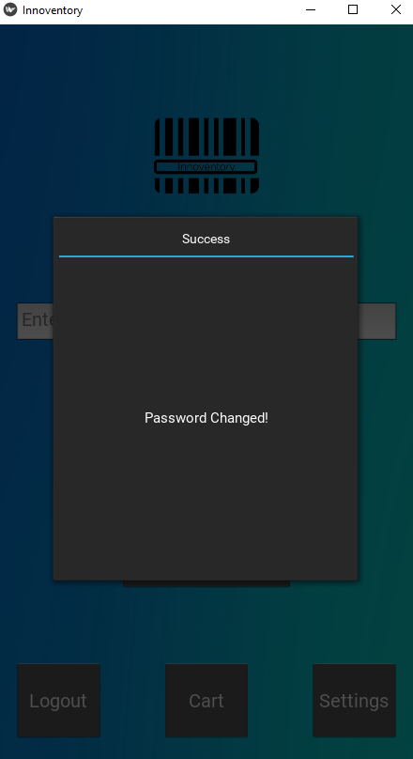

A popup will appear confirming that your password has been changed.

* The “Back” button will take you back to the homepage
* The “Cart” button will show you your shopping cart

